Screenshots :

- TEST SERVER

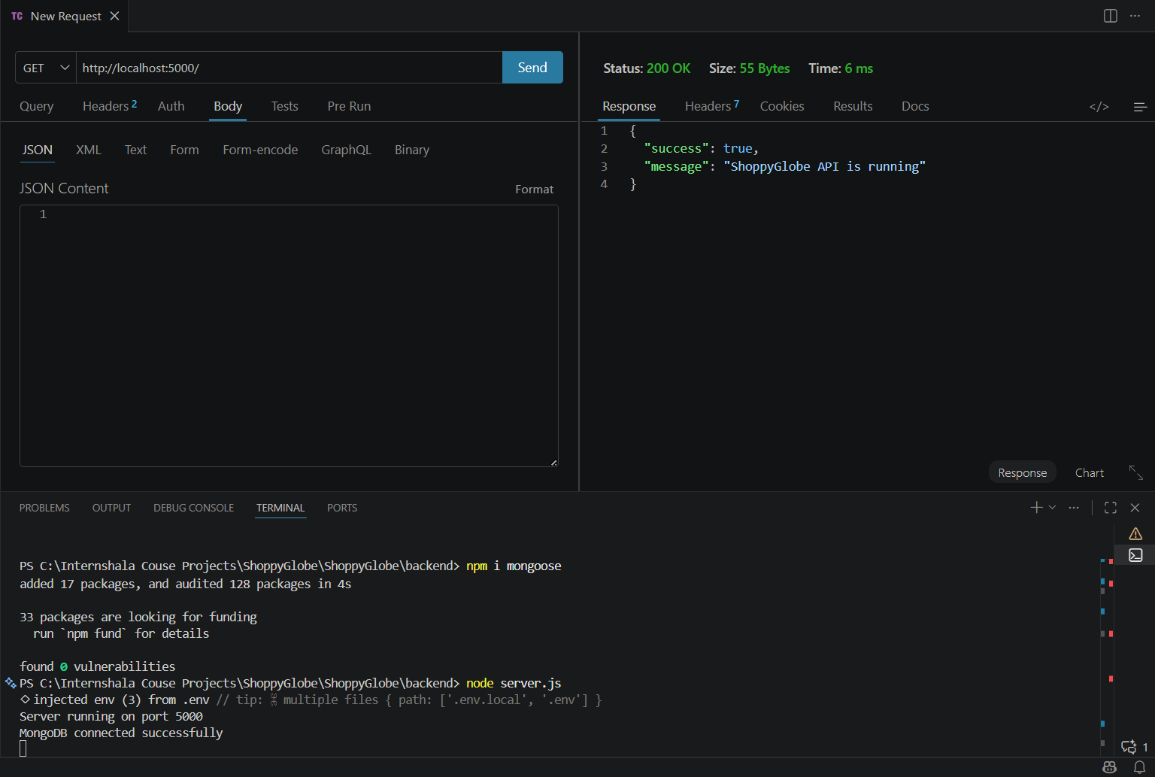

- REGISTER USER

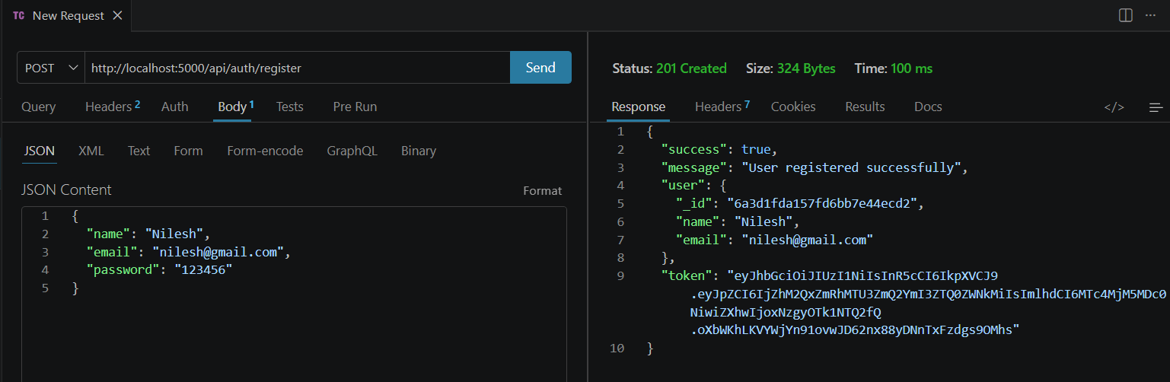

- LOGIN USER

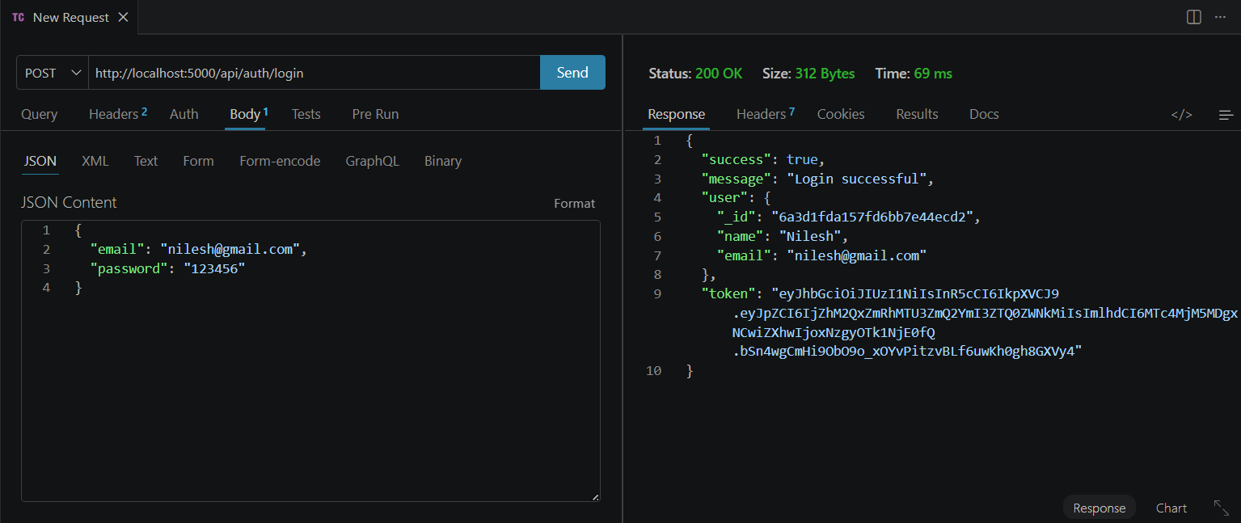

- GET ALL PRODUCTS

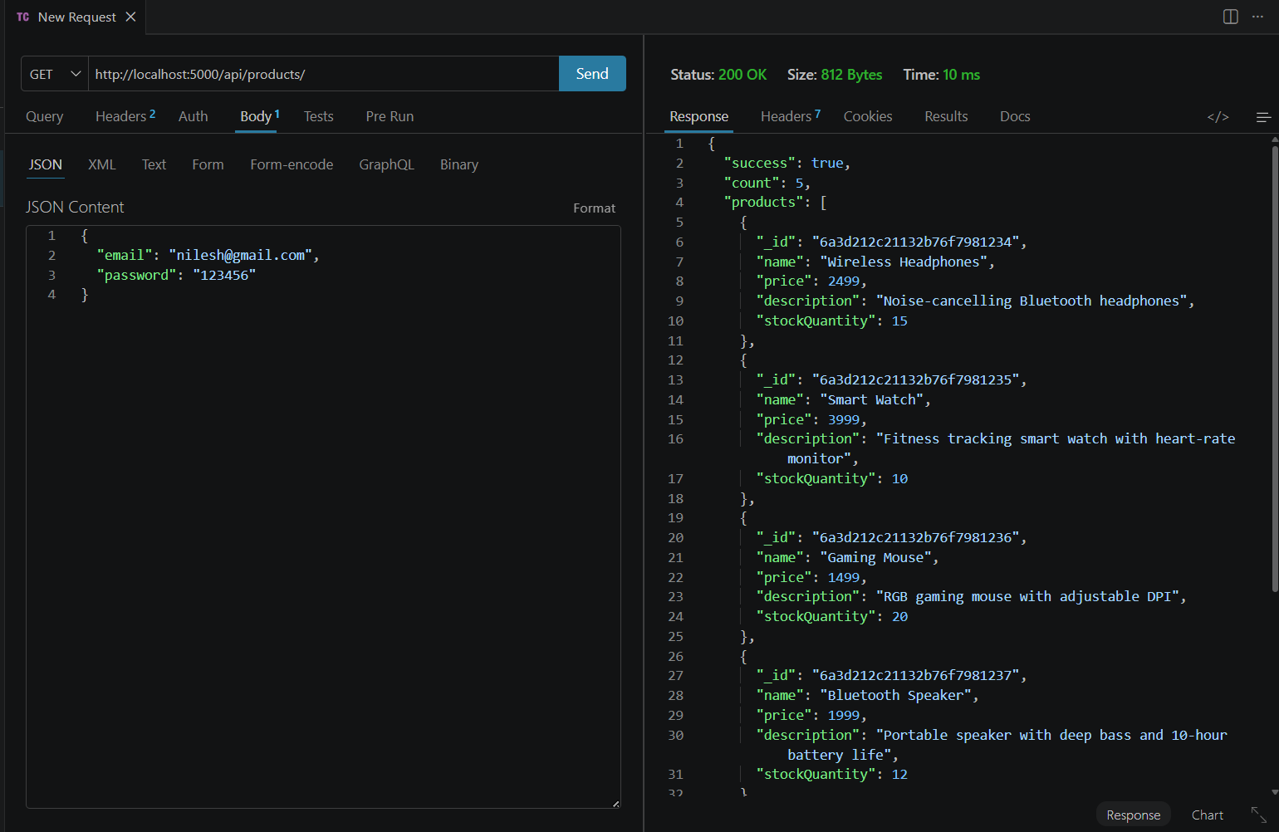

- GET SINGLE PRODUCT

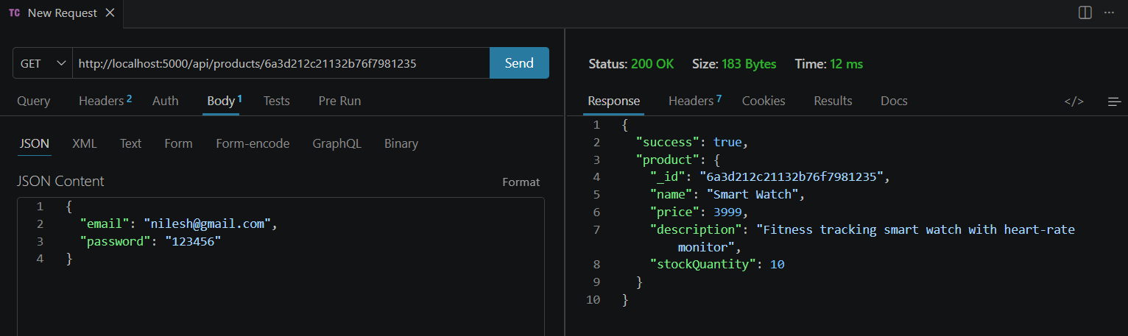

- CART ITEMS

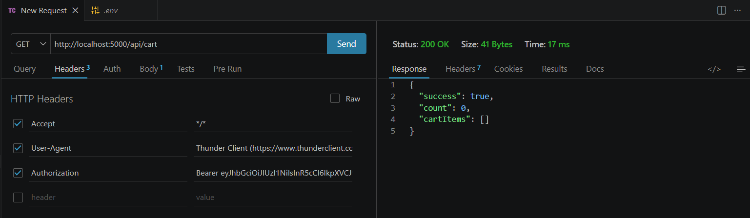

- ADD TO CART

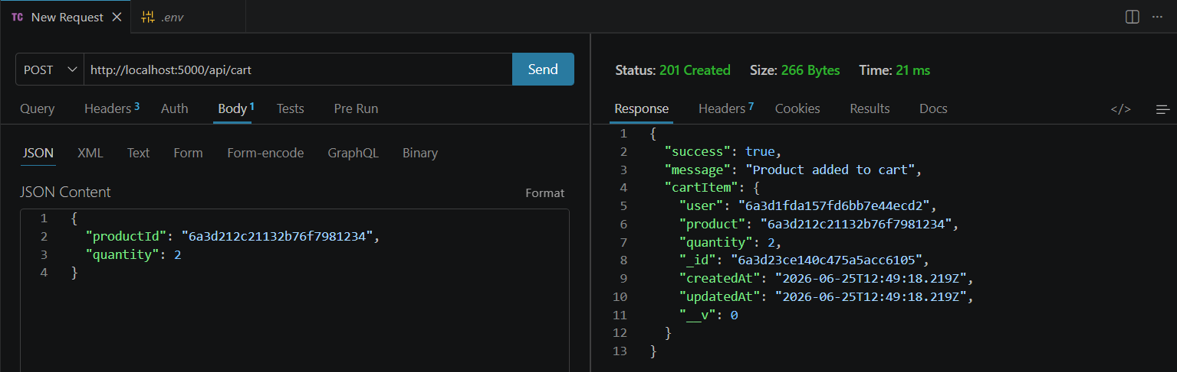

- ADDED CART ITEMS

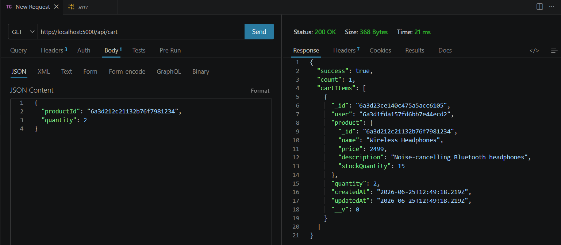

- UPDATED CART ITEMS BY QUANTITY

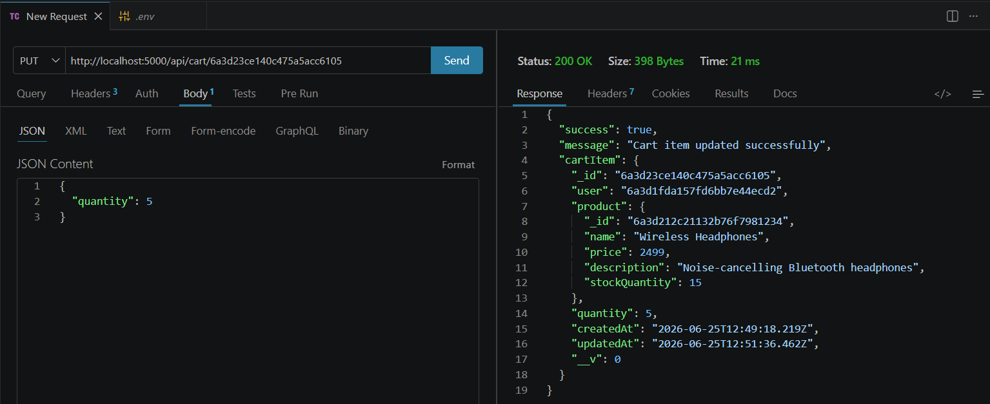

- DELETE CART ITEM
